Matter and Measurement Unit Review Guide

Standard 1: Understanding measurements

Benchmark 1.1 – Choose appropriate units for a measurement, converting between units when necessary.

**Practice Questions**

1. A biologist wants to measure the size of a virus. What units should she use? µm or nm
2. A chemist can experimentally determine the length of a bond between atoms in a molecule. What units should she use? pm
3. State another appropriate way to represent the following measurements.
   1. 9.19x108 nm 919mm or 0.919cm
   2. 4.56x10-7 g 0.456µg or 456ng
   3. 0.00382 pm 3.82nm
   4. 825600 µs 825ms or 0.825s

Benchmark 1.2 – Record measurements to an appropriate precision including uncertainty.

**Practice Questions**

1. Use the following scales to measure the quantities shown. Include the appropriate number of digits and the uncertainty for each measurement.

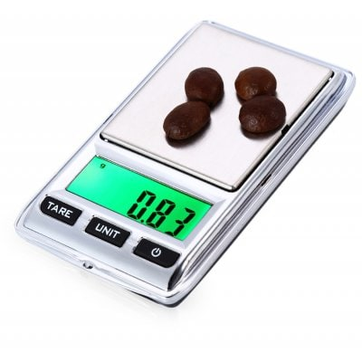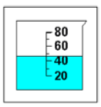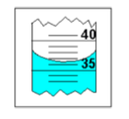 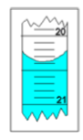

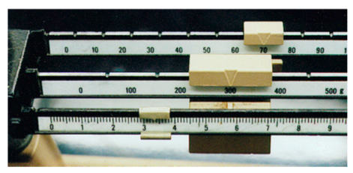

Beaker: (48 ± 5)mL Measuring Cylinder: (35.5 ± 0.5)mL Burette: (20.38 ± 0.05)mL

Digital Balance: (0.83 ± 0.01)g Analog Balance: (373.35 ± 0.05)g

Benchmark 1.3 – Discuss the accuracy and precision of data.

**Practice Questions**

1. Define accuracy. How close a measurement is to a target (known or expected) value.
2. Define precision. How repeatable a measurement is.
3. You want to measure the length of a table. You can use a meter stick or a 30 cm ruler. Both have a smallest division of 0.5cm. Which one will be more precise? Which one will be more accurate? Explain. The meter stick because you will have uncertainty every time you make a measurement. The more measurements you make, the more uncertain your final result will be.
4. In the diagram below, 4 targets are shown. If the goal is to hit the center of the target: a) which target shows *only* precision? b) which target shows precision *and* accuracy? c) which target shows *only* accuracy? d) which target shows *neither* accuracy *nor* precision?

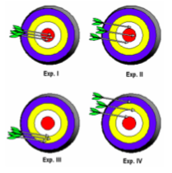

a) Exp. III b) Exp. I c) Exp. II d) Exp. IV

1. Two sets of data are given below. The “true” value of the measurement was supposed to be 16.26. a) Which set of data is more accurate? Explain. b) Which set of data is more precise? Explain.

|  |  |
| --- | --- |
| Set A | 15.32, 15.37, 15.33, 15.38, 15.35 |
| Set B | 16.30, 16.19, 16.24, 16.29, 16.23 |

1. In which of the following examples would the precision of a thermometer be more important than its accuracy?
   1. Determining the identity of an unknown compound by comparing its measured melting point to a reference table.
   2. Measuring the temperature change when a chemical is added to water. You’re measuring a *change*, so the accuracy shouldn’t matter because the difference in temperatures should be close to the same. For example, if the actual final and initial temperatures are 28.3oC and 25.0oC, then the difference is 2.3oC. If the thermometer instead gave temperatures of 32.8oC and 30.5oC, the temperature change is still the same, 2.3oC.

Standard 2: Understanding matter.

Benchmark 2.1 – Differentiate between pure substances and mixtures.

**Practice Questions**

1. Define pure substance. Contains only a single substance, i.e. a single element (nitrogen, oxygen) or a single compound (NaCl, H2SO4).
2. Give an example of a pure substance. Draw a diagram to illustrate your example.

See examples above. The diagram shown here could represent either nitrogen or oxygen.

1. Define mixture. A combination of two or more *different* substances.
2. Give an example of a mixture. Draw a diagram to illustrate your example.

A mixture of iron and nickel

In the diagram, black represents iron atoms and red represents nickel atoms.

Benchmark 2.2 – Classify matter as an element, a compound, a pure substance, heterogeneous mixtures and homogeneous mixtures, including solutions, suspensions and colloids.

**Practice Questions**

1. Define heterogeneous mixture. Particles are unevenly distributed (you can easily see or distinguish each part of the mixture).
2. Define homogeneous mixture. Particles are evenly distributed (you cannot easily see the different parts; it *looks like* a single pure substance).
3. How is a solution different from a suspension? Both are solid-liquid mixtures, but in a solution the solid is dissolved in the solvent making a *homogeneous mixture*, whereas a suspension is a heterogeneous mixture.
4. What test can be used to identify a colloid? Outline how the test works. Tyndall effect. A colloid contains suspended particles too small to see with the naked eye. Shining a light through a sample will cause the light to scatter off the particles making the light beam visible.
5. Classify each of the following substances. Remember that one substance may fit to classifications. For example, a solution can also be classified as a homogeneous mixture, so both classifications should be stated in your answer if the substance is a solution.
   1. Table salt (NaCl)
   2. Vegetable soup
   3. Oxygen gas
   4. Sea water
   5. Soda
   6. Rust (Fe2O3)
   7. Air
   8. Muddy water
   9. Tea leaves in water
   10. Milk
   11. Iron

a. pure substance, compound b. heterogeneous mixture c. pure substance, element

d. solution, homogeneous mixture e. heterogeneous mixture f. pure substance, compound

g. homogeneous mixture h. suspension, heterogeneous mixture

i. heterogeneous mixture j. colloid, heterogeneous mixture k. pure substance, element

Benchmark 2.3 – Choose an appropriate method for separating mixtures.

**Practice Questions**

1. State and outline the process you would use to separate the following mixtures.
   1. Oil and water. Possible answers: a) use a separatory funnel to remove the water layer; b) use a pipet to siphon (suck out) the oil layer.
   2. A solution of copper sulfate (CuSO4). Evaporation/crystallization. Boil off the water and collect the copper sulfate crystals.
   3. Two different types of chlorophyll in plants. Since this involves separating colored compounds in a homogeneous liquid-liquid mixture, you can use chromatography. Place a sample of the chlorophyll mixture on a piece of filter paper or chromatography paper. Place the paper in an appropriate solvent. As the solvent moves up the paper the chlorophyll will separate and can be differentiated by how far up the paper the sample moves.
   4. Sand and water. Filtration. Pour the mixture through a filter paper in a funnel. Collect the sand in the filter and collect the water as it passes through the filter paper.
   5. Vinegar Since this is a colorless, homogeneous liquid-liquid mixture, it must be separated based on the boiling points of the two liquids: *distillation*. Heat until the boiling point of one of the liquids is reached. *Use a condensing tube* to condense the vapor and collect the liquid. Stop heating when the temperature begins to rise above the first boiling point. What’s left in the flask should be the other pure liquid.

Benchmark 2.4 – Differentiate between physical and chemical properties and changes.

**Practice Questions**

See the “Physical vs Chemical Practice” file on Managebac in the Matter and Measurement folder.

Properties

1. P

2. P

3. C

4. P

5. C

6. C

7. P

8. P

9. C

10. P

11. P

12. P

13. P

14. C

Changes

1. P

2. C

3. P

4. P

5. C

6. C

7. P

8. P

9. C

10. P

11. C

12. C

13. P

14. P

15. C

16. P

Part A

1. P

2. C

3. C

4. P

5. C

6. C

7. P

8. P

9. C

10. P

Part B

1. Answer already given

2. Chemical: color change

3. Chemical: color change

4. Physical: phase change, but same substance

5. Chemical: gas produced

6. Chemical: color change

7. Physical: change in shape, but same substance

8. Physical: the color of the food coloring stays the same, so no change in substance.

9. Physical: no new substance formed / Chemical: new substance formed (sugar from starch)

10. Chemical: changes in both color and energy.

Part C

1. F

2. F

3. T

4. T

5. F

6. F

7. T

8. F

9. F

10. F